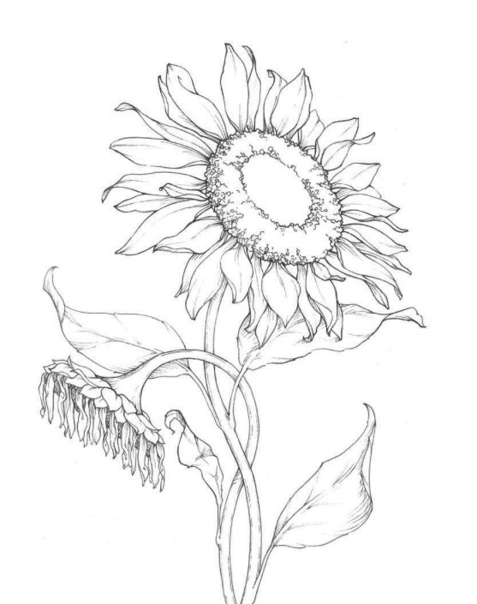
Goose Flight Dinner Menu
  - October 15-22
  - $119 per person

Select one dish from each course
First Course
Farm Terrine
vegetable terrine topped with lavender foam and greens
Soup
white bean & sausage soup with chili oil and hickory sticks
Second course
Served Family style
Moroccan chicken
oven roasted ½ chicken seasoned with Moroccan spices
Pork loin
seasoned with African spice blend and braised stone fruit
Risotto
morel & cremini mushrooms with saffron oil
Course is served with:
roasted beer mustard brussels sprouts served on a sweet potato puree topped with a walnut chili crisp
&
Fingerling potatoes confit in lemon-herb-garlic butter

Chocolate trio
*vegan alternative is available upon request

