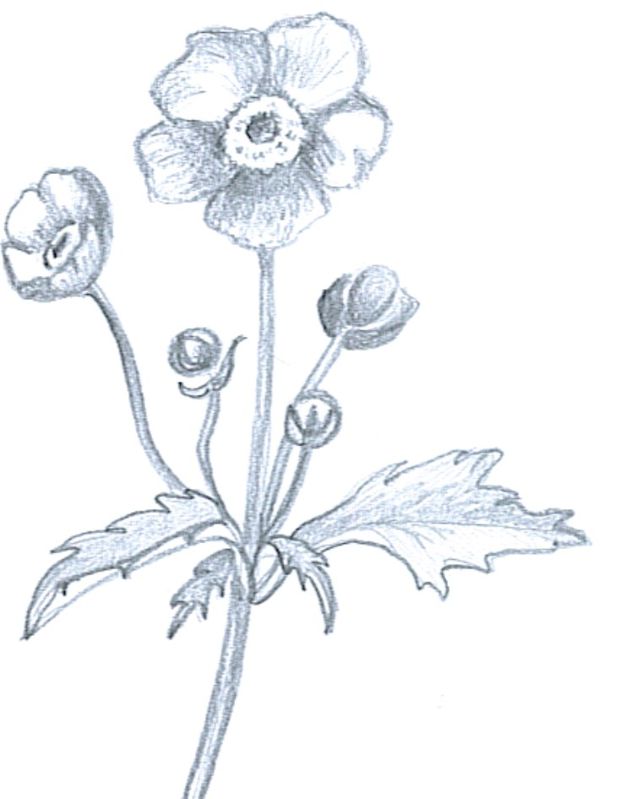
Goose Flight Dinner Menu
  - September 20-October 8
  - $119 per person

Select one dish from each course
First Course
Farm Salad
Garden vegetables in an herbed vinaigrette
Farm Soup
Seasonal soup featuring FortWhyte Farm’s harvest
Second course
Served Family style
Rack of Lamb
grilled and served with mint pesto
Trout
Served in sauce verge

Risotto
With roasted pumpkin and sage
Course is served with:
Courgette mix topped with sharp feta, tapenade, grilled lemon and gremolata
&
pearl couscous with fried capers, mint, and roasted red peppers

Third course
Scorn Cake
Manitoba sweet corn scone cake finished with caramelized honey butter, fresh berries and bee pollen
Sweet Grilled Polenta
Topped with seasonal berries

